5. Solution Proposal – NIST-Aligned Cybersecurity Instructions
Out of concerns brought up in Section 2 and analysis about the severity of threats proposed in Section 4, we have formulated a series of procedural solutions for this Monash project. These solutions are all based on the assumptions mentioned in Section 3 which you can refer to see all the definitions and details of these assumptions. By applying our solutions to Monash project management, the project team will obtain a series of secure procedural guidelines to protect their research data which is part of university’s critical infrastructure by law.
PMBoK-Based NIST Cybersecurity Framework and Guidelines for Monash Project Resources
Now we will present our detailed solution for this Monash project. The solution contains two parts which are PMBoK-based NIST cybersecurity conceptual model and the procedural guidelines.
a) Conceptual Model
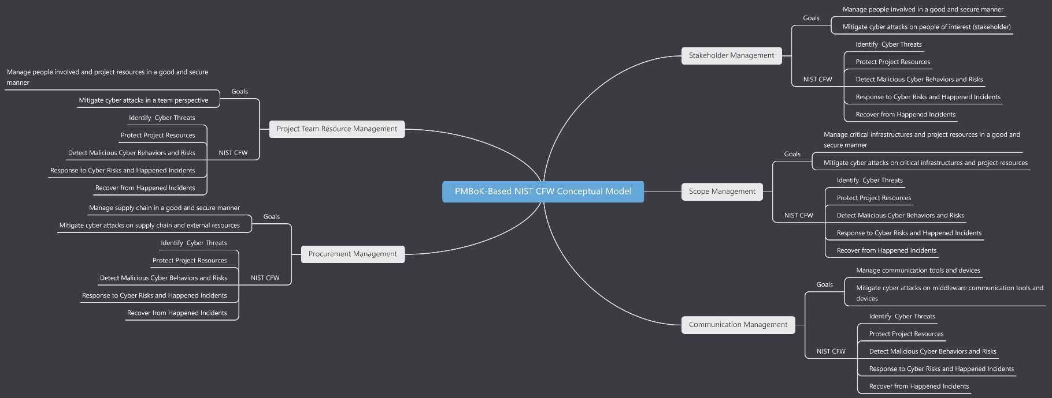
The conceptual model mainly focuses on the 5 selected key areas of PMBoK that have already been defined in Section 3. Based on these key areas, the NIST cybersecurity framework is applied. The classical 5 steps of this framework are refined in order to fit the key areas better, so each of the management will have these 5 actions aiming to protect their respective fields. The goals of the NIST CFW in each of the key areas are also demonstrated in the conceptual model. Below is our diagram.
b) Procedural Guidelines
Scope Management
<Step 1> Identify for Scope Management
- Identify project resources that need to be protected. For example, those resourced defined in NIST Identification categories: asset, environment, governance, risk assessment and its Strategies.
- Determine the methods to protect the project resources. For example, access control, awareness training, etc.
- Determine the risk detection scheme for project resources. For example, detection for anomalous events.
- Determine the response scheme for project resources. For example, analysis and defence mechanism.
- Determine the recover measures when university's critical infrastructures facing loss, modification, damage.
<Step 2> Collect Client Requirements
- Collect client requirements about resources securing.
- Collect client requirements about their trusted protection methods.
- Collect client requirements about their trusted risk detection mechanism.
- Collect client requirements about their trusted risks response mechanism.
- Collect client requirements about their trusted infrastructures recovery mechanism.
<Step 3> Define Project/Product Scope
- Identify which project assets are exposed to danger in product design phase.
- Implement protection in both functional and non-functional features of product.
- Detect the code kill-switch in product design phase.
- Design response to code kill-switch in product design phase.
- List the recovery plan for university in the situation when code kill-switch is turned on.
<Step 4> Build Work Breakdown Structures (WBS)
- Build WBS for identifying project resources that need to be protected.
- Build WBS for determining the methods to protect the project resources.
- Build WBS for determining the risk detection scheme for project resources.
- Build WBS for determining the response scheme for project resources.
- Build WBS for determining the recover measures for university critical infrastructures.
<Step 5> Test Scope
- Make Test plan for efficiently and completely identifying project resources.
- Write test scripts for testing project resources protection.
- Write test scripts for testing risk detection.
- Write test scripts for testing risk response.
- Write test scripts for testing recovery of research data from disaster.
<Step 6> Control Scope
- Manage changes to project resources.
- Manage changes to project resources protection methods.
- Manage changes to risk detection scheme.
- Manage changes to response methods.
- Manage changes to recovery mechanism.
Stakeholders Management
<Step 1> Identify for Stakeholders Management
- Identify people involved in the project and their resources.
- Identify the vulnerability brought by people's lack of awareness of cybersecurity and list the potential chances that people can be hacked by social engineering.
- Identify the detection scheme to detect potential external hacking on employees and employers. Specify how to detect social engineering.
- Identify the risk response to social engineering.
- Identify the recovery mechanism after being attacked by social engineering or other people perspective cyber attacks.
<Step 2> Recruit Stakeholders
- Recruit employees that already have some sense and awareness of cybersecurity.
- Recruit cybersecurity specialist to train the general employees and protect potential vulnerability caused by general employees.
- Recruit cybersecurity specialist to implement the detection mechanism
- Recruit cybersecurity specialist to analyze and respond to the happening cyber attacked that goals for stakeholders.
- Recruit cybersecurity specialist and assets manager that can quickly recover the critical infrastructures of university.
<Step 3> Manage Stakeholders
- Train employees and managers regularly on cybersecurity awareness and mitigation methods.
- Train employees and managers regularly on the procedure of protecting project resources.
- Train employees and managers regularly on detecting potential social engineering risks.
- Train employees and managers regularly on reporting the cyber attacks for cybersecurity specialist to respond to the attacks.
- Train employees and managers regularly on how to recover the critical infrastructures and project resources after a high impact incident already happened.
<Step 4> Monitor Stakeholders
- Monitor and record any malicious or suspicious behaviour of internal stakeholders and any vulnerability of people management.
- Monitor and record the whole protection process on preventing cyber attacks on people involved.
- Monitor and record any detected suspicious logs from internal people.
- Monitor and record responses of social engineering attacks from stakeholders.
- Monitor and record the recover operation from stakeholders each time.
Communication Management
<Step 1> Identify for Communication Management
- Identify reliable communication tools and do due diligence check for them.
- Determine protection scheme for any vulnerability exposed from communication tools.
- Determine detection scheme for detecting potential risks from communication tools.
- Determine response scheme for responding to the data leakage from communication tools.
- Determine recovery scheme for recovering from any damage of data integrity caused by communication methods.
<Step 2> Manage Communication
- Manage changes to communication tools. Do due diligence check before change to another communication tools.
- Manage changes to protection methods for communication tools. Check the effectiveness for protection methods each time when you change it.
- Manage changes to detection scheme for communication tools. Test if the detection scheme work each time when you change it.
- Manage changes to response scheme for communication tools and test effectiveness.
- Manage changes to recovery scheme for communication tools and test effectiveness.
<Step 3> Monitor Communication
- Monitor and record any malicious behaviours in communication perspective. For example, the unsafe communication about research data outside university.
- Monitor and record the protecting history.
- Monitor and record the detection for any research data leakage from communication tools.
- Monitor and record response behaviours for any data leakage or damage from communication tools.
- Monitor and record recovery of communication tools. For example, the message recovery should be stored in case another damage happens.
Project Team Resource Management
<Step 1> Identify for Project Team Resource Management
- Identify the information security roles and responsibilities of the team members, aligned with internal roles and external partners.
- Identify which team resources will be allocated to staff who is responsible to protect including maintenance, organizational assets, controlled tools, vulnerability management.
- Identify which team resources will be allocated to staff who is responsible to detect cybersecurity incidents.
- Identify which team resources and staffs will be deployed when cyber risks occur.
- Identify which team resources and staffs will be applied for recovery strategies after a cybersecurity incident.
<Step 2> Estimate Activity Resources
- Estimate the type and quantities of resources necessary to specific cyber risk.
- Team resources for protection of certain risk should be estimated.
- Team resources for detecting vulnerabilities should be estimated.
- Estimate how much the deployment of respond plan would cost.
- Estimate how much would the recovery strategies cost.
<Step 3> Estimate Recruit Resources
- Analyze and organize the requirement list of team resources for different cyber risks.
- Obtain open-source software and useful data resources from reliable third parties.
- Check the effectiveness of the tools and resources used in the vulnerability detection plan.
- Ensure that the recruited staffs involved in the response work have sufficient capabilities to deal with different cybersecurity incidents.
<Step 4> Train the Team
- Train staffs to identify security risks and get familiar with different functional tools and resources
- Provide the staffs with cybersecurity awareness education, cybersecurity- related duties and responsibilities consistent with related policies, procedures, and agreements.
- Teach staffs how to use various tools to analyze and detect possible vulnerabilities.
- Teach staffs how to deal with different cybersecurity incidents, and incorporate the lessons learned into the plan.
- Train staffs on the use of repair tools and methods of executing repair plans.
<Step 5> Manage the Team
- Allocate staffs to related department and team resources are inventoried.
- Set the content related to team discipline in the team charter and clarify the sensitive information and resources that need authenticated access.
- Monitoring for unauthorized personnel, connections, devices, and software is performed.
- Establish good connection with the detection department to ensure that cybersecurity incidents can be reported to the response department in time.
- Ask staffs to use storage devices that comply with the organization's specifications in a safe manner for data backup when necessary.
Procurement Management
<Step 1> Identify for Procurement Management
- Identify the organization’s requirements for reasonable cybersecurity resources and potential sellers.
- Identify the necessary protection level of procured software and hardware.
- Identify the necessary tools and data resources for detection.
- Identify what equipment can guarantee an efficient response to cybersecurity incidents and third-party services that can be relied on.
- Identify the secured and reliable storage devices for the recovery.
<Step 2> Do due diligence check for procurement
- Choose a trusted seller to trade, identify the potential business impacts and likelihoods.
- Make sure the procured resources comply with cybersecurity standards.
- Make sure the seller has not concealed product defects and potential vulnerabilities.
- Make sure the seller can response with necessary security risk information in time.
- Make sure the procured resources could be recovered.
<Step 3> Monitor procurement
- Confirm that the content in the contract complies with laws and standards, and analyze whether the seller’s product has cyber risks.
- Confirm that the product has passed the integrity check mechanism in the contract.
- Clarify possible security vulnerabilities in the seller’s products and the attribution of responsibilities in the contract.
- Clarify that the seller should agree with voluntarily share information about security risks and respond to the purchaser in time in the contract.
- Reach an agreement with the seller on after-sales service to guarantee the maintenance and repair of the procurement.

